For Immediate System Modification:
Status
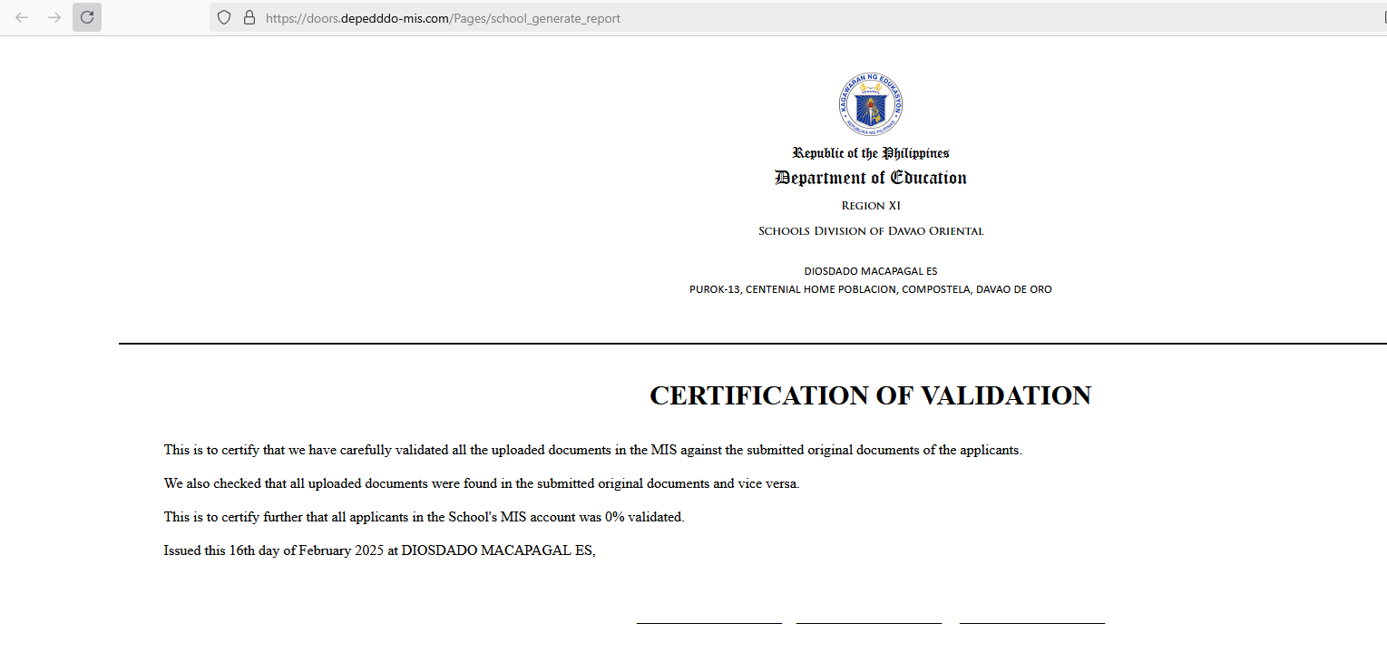
Under school account, make the letterhead dynamic kai SDO Davao Oriental pa ang nag appear
Email: no-reply@depeddavor.com is being used in sending login credentials after applicant signup

